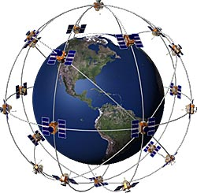GPS and Tracking
Advanced Satellite Tracking -- The History and Evolution of Wireless Telematics and Telemetry Services

Joe Jesson, KB9LZB

TCF Agenda:

- Why should we experiment with GPS?
- How does GPS work?
- Getting inside of GPS Specifications
- GPS Receiver Technology
- Tracking and Sensor Remote Monitoring

According to Alan A. Varghese, senior director of semiconductor research at ABI Research in Oyster Bay, N.Y. GPS shipments are growing at the rate of 31% a year until 2009. Costs have also dropped dramatically and complete GPS chip sets are available for $8.00 and board-level GPS units are now in the low $20.00. Look for GPS to be ubiquitous and most automobile mfg plan to embed TWO GPS chip sets in 2009+ models! Let’s take a look on how this is implemented and how to measure and interpret the GPS strings.
The Global Positioning System (GPS) is a satellite-based navigation system made up of a network of 24 satellites placed into orbit by the U.S. Department of Defense.
How it works
GPS satellites circle the earth twice a day in a very precise orbit and transmit signal information to earth. GPS receivers take this information and compares the time a signal was transmitted by a satellite with the time it was received. The time difference tells the GPS receiver how far away the satellite is. With distance measurements from a few more satellites, the receiver can determine the user's position and display it on the unit's electronic map.

GPS History
- The first GPS satellite was launched in 1978.
- A full constellation of 24 satellites was achieved in 1994.
- Each satellite is built to last about 10 years. Replacements are constantly being built and launched into orbit.
- A GPS satellite weighs approximately 2,000 pounds and is about 17 feet across with the solar panels extended.
- Transmitter power is only 50 watts or less.
GPS satellites transmit two low power radio signals, designated L1 and L2. Civilian GPS uses the L1 frequency of 1575.42 MHz and the signal generally line-of-sight with expected levels of –140dBm A GPS signal contains three different bits of information — a pseudorandom code, ephemeris data and almanac data. The pseudorandom code is simply an I.D. code that identifies which satellite is transmitting information. You can view this number on your Garmin GPS unit's satellite page, as it identifies which satellites it's receiving.
Ephemeris data, which is constantly transmitted by each satellite, contains important information about the status of the satellite (healthy or unhealthy), current date and time. The almanac data tells the GPS receiver where each GPS satellite should be at any time throughout the day. Each satellite transmits almanac data showing the orbital information for that satellite and for every other satellite in the system.
Typical GPS Specifications listed below…. we will go through each parameter and discuss the importance of each in the real world:

The GPS receiver is to be optimized for low power applications, providing minimal power consumption and time to first fix (TTFF) under cold start conditions. However in some applications the GPS receiver is operated continuously, under control of the 3rd party application, with anticipated increased position solution accuracy. Operating requirements are as follows:

- Power Consumption: 180 mW typical, 200 mW maximum.
- Cold Start TTFF: < 45 seconds @ 95% success rate.
- Cold Start Accuracy: 99% < 10 meters.
- Message Format: Minimum NMEA GGA, RMC, GSV and GSA message types, at a rate configurable by the application processor.
- Information: location, speed, heading and time (desirable: odometer).
- Information Rate: Each message type sent once per second by default, changeable by command.

Operating Modes
The selected GPS receiver design must continuously maximize the number of locked satellites to improve the accuracy of the position solution. The application processor may power the GPS receiver continuously or it may power it down once a position solution is provided. Prior to power down, the application will store the most recent position solution then send the same to the GPS receiver following the next power-up, to aid cold start TTFF.
The GSV NMEA message must accurately report the number of locked satellites, such that the 3rd party application can infer the quality of the current position result. Alternatively, if the GSV NMEA message is not provided, the GPS receiver must be able to be commanded to operate in the following modes:

- 2D/3D Automatic: The position solution can be of type 2D, though the GPS receiver provides 3D position solutions when possible.
- 3D Only: A position solution is provided to the application processor only if it is of the 3D type (latitude, longitude, altitude) using a minimum of 4 GPS satellites.
In addition, the GPS receiver shall be able to detect an open or short circuit condition on the active GPS antenna, and report this anomalous condition via its serial port to the application processor.
Note: It is expected that the application processor is equipped with a GPS pass thru mode, whereby the application RS232/RS485 serial link is directly connected to the GPS receiver. In this mode an external device may take advantage of any available native capabilities of the GPS receiver.

Antenna Interface
A commercially available active GPS antenna will be used in customer applications, having a gain of between 6 and 32 dB (including cable loss). At the GPS antenna port, the interface specification is as follows:
- Input Impedance: 50 Ω
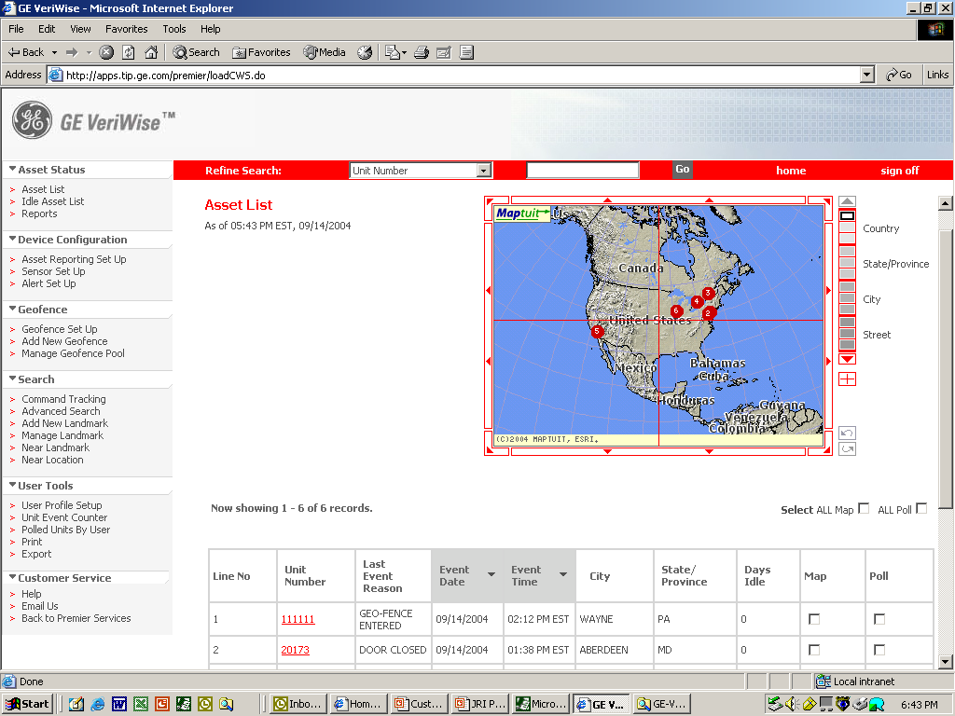
- VSWR: 2.0 maximum
Web or XML
Geo fences
Alerts
Low battery messages
Reports
Sensor enable/disable
User rights control
- Output Voltage: 3.0 ± 0.3 VDC
- Output Power: 20 mA maximum
- ESD: ± 8 KV

Global Asset Tracking Unit
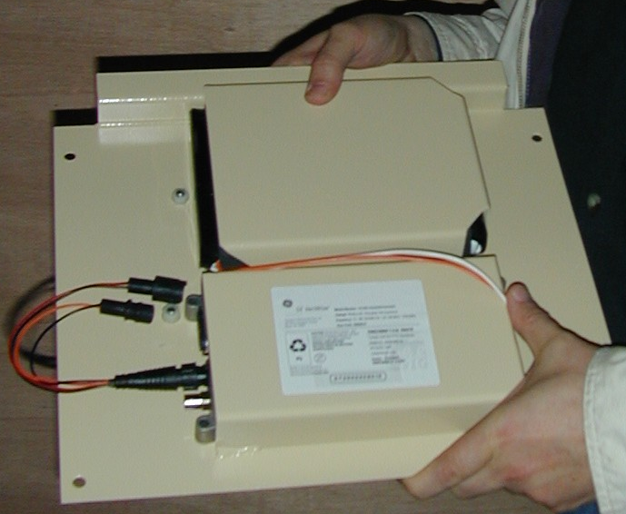

Accuracy Field Test Results and Predicted GPS Accuracy Graph :

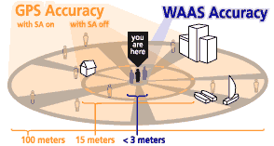

NMEA DIAGNOSIC TOOL
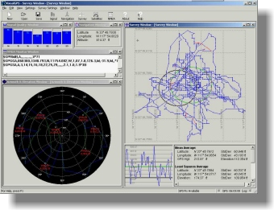

References:

Visual GPS NMEA Tool: http://www.visualgps.net/VisualGPS/default.htm
GPS Frequency Reference: http://www.rt66.com/~shera/index_fs.htm
Onstar NMEA Monitoring: http://www.openminds.net/onstar/
Automatic Position reporting Tool: http://web.usna.navy.mil/~bruninga/aprs.html

